Lab 8: Inheritance
Objective:
- The objective of this lab is to teach students how to implement inheritance in C++.
Learning Outcome:
- After this lab, students will be able to implement inheritance.
Problem Statement
Write a C++ Program to create a base class Employee that stores the employee's name and ID. Derive a class Engineer from Employee that adds the following additional attributes:
- specialization (e.g., Software, Civil, Electrical)
- experience (in years)
- projectName (name of the current project)
The program should input and display all details of an engineer using appropriate methods. This program should demonstrate how data and behavior from the base class are inherited and extended in the derived class.
Sample Output
After running your program, the following output screen should display.
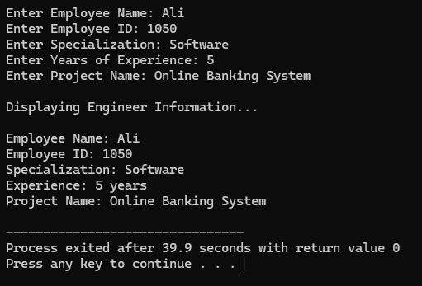
Practice Questions:
Practice Question 1:
Write a C++ program for the following:
Create a base class Book with data members: title and author. Derive a class EBook that adds fileSize (in MB) and format (e.g., PDF, EPUB). Your program should input and display all details of an EBook.

Practice Question 2:
Write a C++ program for the following:
Create a base class User with attributes username and email. It should include getter and setter functions. Derive two classes:
Admin, which adds a method accessControlPanel()
Member, which adds a method browseContent()
In main() function, create objects of both derived classes. The program should input and display the username and email using inherited methods, and then call the respective methods of the Admin and Member classes to display their specific functionalities.

